**TITLE: LIBRARY MANAGEMENT SYSTEM**

**CANDIDATES NAME: MATTA KIMANI**

**REG. NO.: 20/03569**

**SUBMISSION DATE: 21/10/2022**

**SUPERVISSOR: COLLINS ONDIEK**

**COURSE: BACHELOR OF SOFTWARE DEVELOPMENT**

Declaration

This report is my original work and is prepared as a partial fulfillment for the Bachelor of Software Development

**Table of contents**

**Declaration Pages**

**CHAPTER 1 1.**

**CHAPTER 2 6.**

**CHAPTER 3 8.**

**CHAPTER ONE**

**Introduction**

* **Goal:** Build a web portal to manage employee/book records for the newly built University of Code which has no Library Management System.
* University of Code library systems are manually operated by a group of people. Many employees are involved in the library management, such as keeping records regarding books and students (borrowers), manually checking books, keeping records on issued books, etc. All of these things have to be carried out manually. It's a considerably more severe difficulty if the library's content management is extensive. On the other hand, keeping a large maintenance staff can be expensive and inefficient for a library. Manual record-keeping is also not a reliable method.
* A manual method makes it hard to find a book strictly at once from a borrower's standpoint since it is not cleanly organized. Sometimes the user might be searching for a book that is not available in the library. People become annoyed in these situations. Therefore, there should be a reliable way to manage the library system.

**PROBLEM STATEMENT**

Problems to be solved are:

* Lack of space
* Improper management
* Time consumption i.e., Too much time taken when borrowing or returning a book
* Tracking a book is difficult.
* No central database can be created as information on the books is not present

**PROPOSED SOLUTION**

The system proposed should:

* Have fast access to database
* User friendly
* More storage capacity
* Have less error
* Have a search facility
* Have quick transaction

**OBJECTIVES**

**The objectives are:**

* To reduce time consu**mption.**
* To track lost books and books being borrowed and returned.
* To design a system with more storage.
* To develop a system with a quick transaction.

**SIGNIFICANCE OF THE PROJECT**

The benefits are:

* improve the library services.
* Help the Liberians with management information.
* Help the librarian in reporting on the various operations of the library.
* Increase the rate at which Tasks are completed accurately.

**CHAPTER TWO**

**Literature review**

**Background Information:**

E-Library Management System is an application that refers to library systems that are generally small or medium in size. A librarian uses it to manage the library using a computerized system to add new books, page sources, and other things. The system includes different login options for students and faculties. All the books are arranged in such a way that anyone can quickly find a book they are searching for. This significantly reduces the time spent searching for books. In addition, they can instantly know if the books they are looking for are available in the library. A trending segment is included in this system. It shows which books the majority of students and faculties have recently read. Apart from that, the system's algorithm recommends books based on what they have already read. Users can see how many times a book has been read and who has read it. They are also able to see the books their friend has read. Books and user maintenance modules are included in this system to track the users using the library and a detailed description of the library's books. It can receive orders to borrow books from users, keep track of the borrowed books, and collect fines for books returned after the due date. With this computerized system, there will be no loss of book records or member records which generally happens when a non-computerized system is used. These modules can help the librarian in managing the library with greater ease and efficiency than non-computerized library systems.

**Related/ Similar Software Systems:**

The E-Library Management System has several unique features that set it apart from other similar systems on the market. Most systems do not provide login option for faculties. Only students are permitted to access them. But this system has different ways to login for faculties and students. The trending and recommend modules make it completely unique from any other systems available out there. Furthermore, all of the algorithms used in the system are designed to be extremely efficient, ensuring that the system always operates at the fastest possible speed. It saves the users a large amount of time.

**CHAPTER THREE**

**Methodology**

A library management system helps all the stakeholders in the system. Be it librarian, faculty, student, or even the management. the high-end software allows you to view the books in the library, students that have issued them, and when it is due.

**Tools going to be used are:**

* HARDWARE CONFIGURATION: PC, HARD DISK, Monitor, Key Board, Mouse.
* SOFTWARE CONFIGURATIO: Operating System (Windows 7, Windows 10)
* Language: Java, JAVASCRIPT.
* IDE: NetBeans IDE, Selenium IDE
* Database Management System: SQL.

**Product development work breakdown**

Use-Case diagram is used for this breakdown.

**Use-Case Diagram:**

Here there is one Actor which is Librarian, 6 main use cases, (under the line there are some extensions point and some extend use cases in this System.

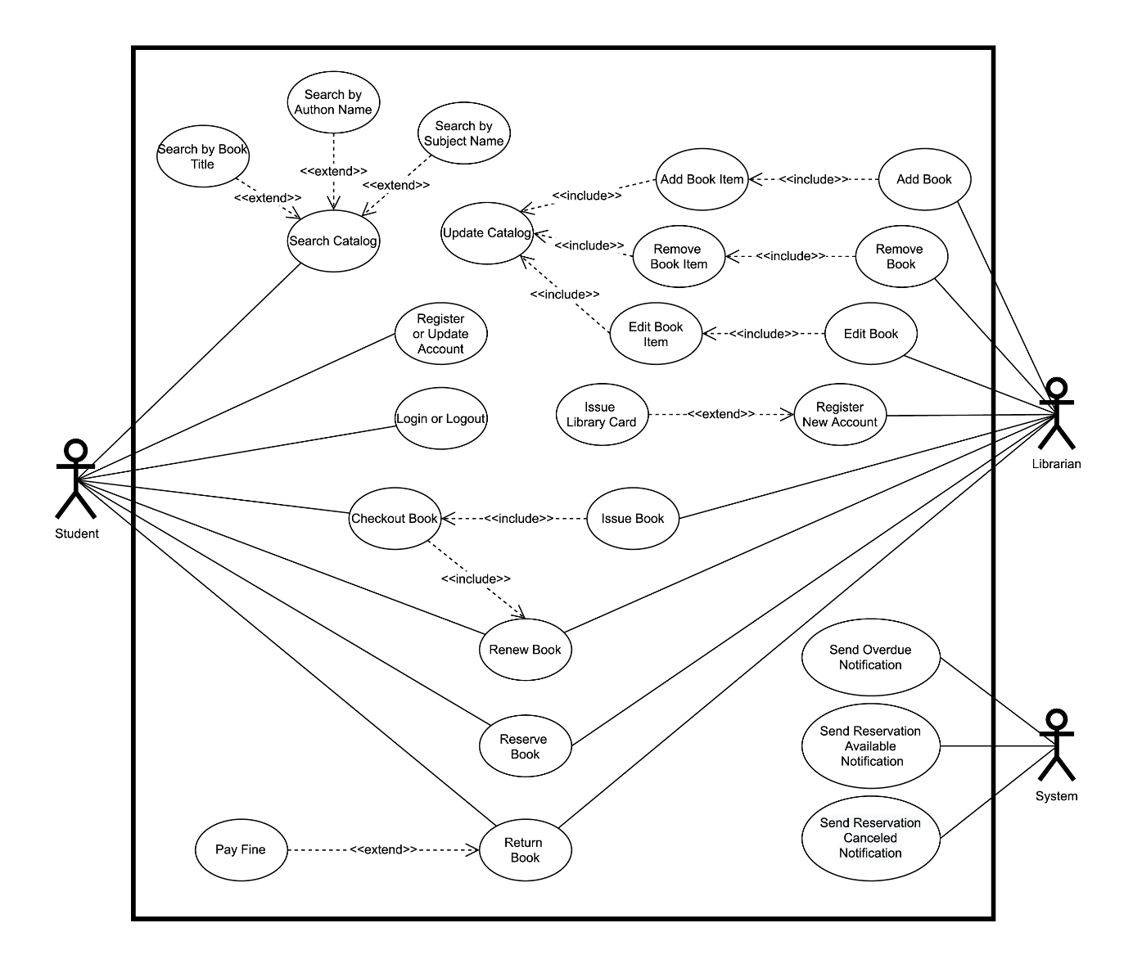

**Note:**

* The time allotted here is subject to change based on client availability to give details/ guidance to the implementation team

|  |  |  |  |
| --- | --- | --- | --- |
| # | Phases | Details | Duration |
| 1 | Understand requirements | Requirements will be collected and documented in use case format. | 1/2 weeks |
| 2 | Architecture and design | Architecture of the product will be determined. Detailed design will be created to start the actual development. Technology platform will be decided. Design for data storage (database design) will be created. We will also create an initial test plan and test cases in this phase. | 1/2 weeks |
| 3 | Coding/ Implementation phase | Implementation of the use cases will be done based on established practices and standards. Unit testing may be enforced for cleaner code. | 5 weeks |
| 4 | Testing | Testing will be done based on test plan and test cases. User acceptance testing will be done in closed groups. Bug fixes and regression testing will be done here. | 1/2 weeks |
| 5 | Deployment | Deploy the system and make it live for general users. | 1/2 weeks |
| Total Time | | | 7 weeks |

**BUDGET**

**Plan of Work**

A structured project management approach is being followed.

Note:

* The time allotted here is subject to change based on client availability to give details to project team.
* The total price is all inclusive.

|  |  |  |  |  |
| --- | --- | --- | --- | --- |
| # | Phases | Details | Duration | Cost |
| 1 | Initial works | Define the project in detail based on targeted business case. Stakeholders need to be identified, information should be collected to understand feasibility and business values. | 1 weeks | KSH. 10,000 |
| 2 | Planning phase | Clearly define specific and attainable goals. We will set a timeline, decide on project milestones and determine project deliverables in this phase. Works will be done in collaboration of all team members. Project will be broken down into smaller parts in this phase for better handling | 1 weeks | KSH. 20,000 |
| 3 | Execution phase | Project development team will be created and works will be handed down to appropriate resources. Project progress will be monitored based on the schedule created in the previous phase. Design, development and testing of the product will be done by the development team | . 7 weeks | 1,00,000 |
| 4 | Closing things up | Look back at things and determine success level of the project. | 1 week | KSH 5,000 |
| Total | | | 10 weeks |  |